A Side
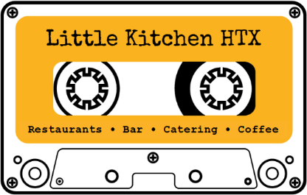
Open 7 days
Monday to Thursday 8:30am-8:30pm
Friday 8:30am-8:30pm
Saturday 10am-8:30pm, Sunday 10am-2pm

sides & appetizers

black-eyed pea hummus $8 V
olive oil sumac pita crudites (can be GF)

sesame chicken wings $9
sweet nutty a little spicy

LK crawfish fries $10 GF
fondue house made fries

famous mac ‘n’ cheese $6 V
cheetos green onions

roasted cauliflower $7 GF VG
spiced with curry green onions sesame seeds

LK mashed potatoes $5 GF

LK green beans $4 GF VG
roasted seasoned

fries $5 GF
made in-house

soups

soup of the day or tomato bisque $6
sourdough croutons and pecan pesto

salads

sunflower crunch $8 GF V
mixed greens cabbage romaine cherry tomatoes carrots radish red onion sunflower seeds
tahini lemon honey vinaigrette

fried quail caesar $16
romaine kale croutons shaved parmesan
creamy garlic dressing… without quail $10

+ chicken + avocado + tofu $4

sandwiches

LK burger $11
double meat cheddar
pickles secret sauce challah bun

cauliflower tacos $9 V
roasted veg cilantro cotija pickled
red onion charred scallion aioli
corn or flour tortilla (be GF or VG)

portabella burger $9 V
roasted mushroom black bean patty cheddar
pickles secret sauce challah bun

country ham $8
smoked ham white cheddar lettuce bbq chips
pickles thunder island sauce milk bread

entrees

honey butter chicken $8
boneless buttermilk fried local honey

ribeye $20 GF
charred greens beans
LK mashed potatoes horseradish

wild boar bolognese $13
egg noodles boar ragu parmesan

parmesan chicken $13
LK broccoli fried garlic compound butter

grilled salmon $16 GF
roasted cauliflower green onion sesame seed

mushroom pad thai $11 GF VG
rice noodles cilantro tofu peppers
green onion sesame seeds sweet chili

chicken ‘n’ waffles $12
maple syrup honey butter

chicken fried steak $15
LK green beans
LK mashed potatoes black pepper cream gravy

B Side

coffee

espresso $2.50
americano $2.75
johnny cash
12 oz. $3.50
16 oz. $4.50
cortado $3.75
flat white $4
cappuccino $4
latte $4
cold brew $4
drip
12 oz. $2
16 oz. $3
hot tea $2

coffee add-ons
extra shot $1.50
caramel $0.50
vanilla $0.50
chocolate $0.50
extra flavor $0.50

alternative milks
oat $0.75
almond $0.75

beverages

topo chico $3
sparkling water $2

iced tea $3
lemonade $3

diet coke $2
soda $3.50

kombucha $4.50
juice $3

wine

zonin prosecco
$8.50/$32
bliss sauvignon blanc
$8/$30
liberation rose
$8/$30
shannon ridge chardonnay
$8.50/$32
liberation pinot noir
$8/$30
liberation cabernet sauvignon
$8/$30
diamandes cabernet sauvignon
$9/$34

beer

bud light $3
8th wonder dome fauxm $3
8th wonder haterade $3
lone star $4
dos equis $5
shiner bock $5
st. arnold lawnmower $5
sigma double ipa $7

on tap

draft $3

other

st. arnold dry cider $5.50
white claw $5

full bar!

